ITP 120VT Module 4
Laboratory

In the Assignment tab of our Portal page download the file itp120mod4_1718.jar and itp120mod4deitel.jar. The second one has the examples from the textbook. The first one is the one we will be looking at in this module. There are a number of packages in this file. YOU WILL ONLY BE TURNING BACK IN A PACKAGE NAMED dwolffmod4 (except with your name) with the programs shown at the bottom of this document.

- Look at the examples of reading APIs from chapter 16 of your textbook (9th edition) or chapter 14 (10th edition) and watch the movie on this material. Java provides wonderful classes for our use! We need to get used to understanding how to use these. We need to be able to use both the static methods and non-static methods.
- Look at the examples I provide in the itp120mod4.Ex1.methodsFromJavaAPIs package. Open the Java APIs for the classes and study them as you read the comments included in the files. Play with the code and see what you can change and add. We will combine the concepts of reading APIs with class structure later in this lesson.
- Now look at the package named itp120mod4.Ex2.staticmethods. Look through the examples, especially concentrating on method definitions and method calls from static methods to static methods. I am not assigning any program as such on this but we will be using method definitions and method calls in every program we do from here on out.
- We will continue our study of the heart of Java in this module! Classes! Really understanding this module is critical to your success in Java.
- To remind ourselves: Classes are made of two things - instance variables (or fields) and methods. Instance variables are the properties or attributes that describe a class and should be nouns. They must always be private unless you have reasons to make them have a different access modifier. Methods are the verbs or actions for the class.
- Let’s look at classes in more detail. Look in the itp120mod4.Ex3.classes package. NOTE: the rest of the programs indicated below are in this package.
- Open up the Invoice and InvoiceDriver programs and read the comments carefully as you study the code. Run the programs. Do the same for Cookies and CookieDriver. Do the same for SmartRobot and SmartRobotDriver.
- Open up Day and DayDriver. Day is a very useful class!! Look at the JavaDocs above each field and method in this class. We will learn how to generate these in Eclipse later. Play with the DayDriver. Add code to try other methods in the Day class
- To do: Let me walk you through an example, describing it step-by-step. Open up the document named ThoughtsOnClasses.doc. You will be creating a Widget class and a Widget driver. Type (or copy and paste) with me as I try to again explain classes. Include these in your final submission. Note the comment that we are using an array in this application. You are not expected to understand this at this point (just copy the code). We will look at these in the next module.
- Since instance variables are private, they don’t do much for other classes since the other classes cannot directly access them. We, therefore, must rely on our methods which are the verbs or behaviors for the class. All of the power of Java lies in writing methods, methods, and more methods! YOU MUST UNDERSTAND METHODS!! Look at the Word document named MethodsInANutshell.doc (it is included in this assignment in the portal). Study the four ways to use Java methods.
- To do: Look at Stock and StockDriver. Get these programs to run. We will be keeping track of both our cost and the fair market value of our shares of stock. There is sample output for this program at the bottom of this document.

- To Do: VACATION AND VACATIONDRIVER
In this exercise, you will write a Java class for keeping track of sales for a company that sells vacation packages. Write the Vacation class with a vacation object being described by three instance variables: vacationName (a String), numSold (an integer that represents the number of those vacation packages sold), and priceEach (a double that is the price of the vacation package). I only want three instance variables!! The class should have the following methods:
  - A constructor that has two parameter – a String containing the name of the vacation and a double containing its price. The constructor should set the other instance variable to zero.
  - An empty constructor
  - All getters and setters
  - A method updateSales() that takes a single integer parameter representing the number of additional vacations of that type sold. The method should add this number to the numSold instance variable and return nothing
  - A method totalValue() that takes no parameters and returns the total value of that vacation inventory
  - A toString() method that returns a string containing the name of the vacation and the number sold, the price each, and the total value

- Write a VacationDriver program that uses Vacation objects to track the sales.
- Ask the user for the number of different types of vacations and how many sales people are selling them.
- Using a nested for loop, get the information for the vacations (see outline below). After each prompt, call the updateSales() method to update the number of vacations sold.
- After all the data has been read in for a given type of vacation, call the toString() method for this to print out their information. Then loop to get the next vacation.

Here is an outline for you

public static void main(String[] args)
{
// ask for the number of vacations and read it into numVacations
// ask for the number of sales people and read it into numPeople

// beginning of loop for number of vacations
for(int i = 0; i < numVacations; i++)
{
//ask for the name and price and read these into variables
// create a Vacation instance using the data obtained above

for(int j = 0; j < numPeople; j++) // loop through the sales people {
// ask for the sales for the current vacation and read it in
// call updateSales with this number

}

//print out this vacation info
} //end of inner for loop
} //end of outer for loop
} //end of main

- To Do: QUOTE AND QUOTEDRIVER. NOTE: There is a start file for this.
Write a class named Quote with a single instance variable named quote that is a String. Write the no-argument and full constructor and the getter and setter. The class should also have methods returns the following:
- The number of characters in the quote
- The quote in all uppercase letters
- The quote in all lowercase letters
- The first character in the quote
- the number of vowels in the string
- the number of consonants in the string.
- A method that asks the user to enter a character. The program should count and return the number of times that the specified character appears in the string.
Here is a UML document for the Quote class. Very cool! Shows the fields and methods. Make certain your methods have the signature seen below.
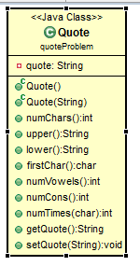

Demonstrate the class in a program named QuoteDriver that performs the following:

- The user is asked to enter a string.
- The program displays a menu giving the user a choice of the methods above. The user should also have a choice of either entering another String or of exiting.
- The program performs the operation selected by the user and repeats until the user selects to exit the program.
SEE BOTTOM OF DOCUMENT FOR MORE INFORMATION ON THE QUOTE/QUOTEDRIVER APPLICATION. NOTE: We are considering y always a vowel just to make it easier.

- Associations are when an instance of a class is a field in another class. Let’s look at a more complete example that uses associations. We will be looking at a class for Sales that has a field that represents the Customer that made the purchase and another that has the Inventory item purchased. Study the code in itp120mod4.Ex4.sales.
- We have three classes and a driver. The three classes are connected by associations (has-a relationships). A UML diagram is very useful for seeing this relationship. Study and understand the Sales application code.

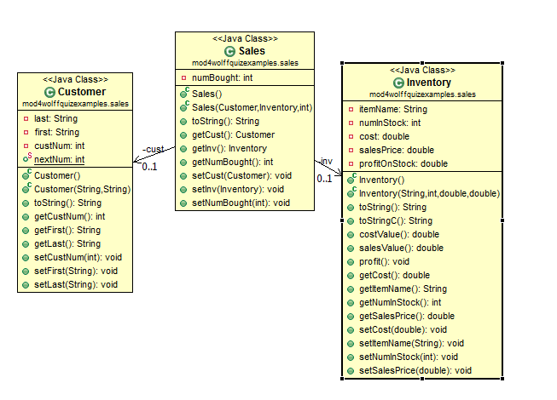

- Association example Carpet Calculator – see UML diagram below – this is an association which is a new concept for us. If you remind me, we will work through the Nursery example I have in our jar file which will also help you with this concept.
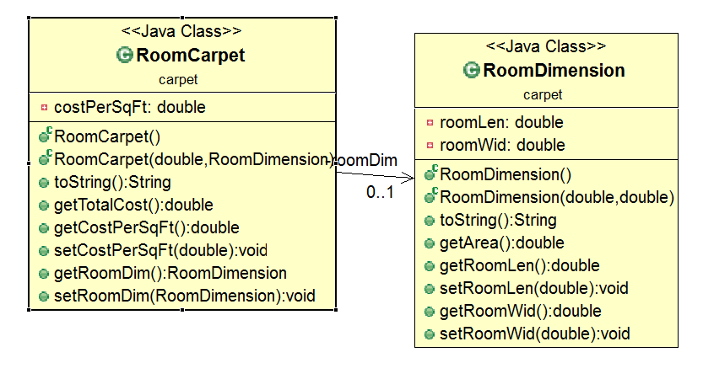

The Westfield Carpet Company has asked you to write an application that calculates the price of carpeting for rectangular rooms. To calculate the price, you multiply the area of the floor (width times length) by the price per square foot of carpet. For example, the area of floor that is 12 feet long and 10 wide is 120 square feet. To cover that floor with carpet that costs $8 per square foot would cost $960. (12 X 10 X 8 = 960.). We need a RoomDimension class that has two fields: one for the length of the room and one for the width. The RoomDimension class should have two constructors, a toString() method, getters and setters, and a method that returns the area of the room. (The area of the room is the room’s length multiplied by the room’s width.). Next we need a RoomCarpet class that has a RoomDimension object as a field. It should also have a field for the cost of the carpet per square foot. The RoomCarpet class should have two constructors, a toString() method, getters and setters, and a method that returns the total cost of the carpet. Once we have written these classes, we use them in our CarpetCalculator class. See the code in our start files for this application.

- To do: You work at a nursery and keep track of the inventory of plants available. Create a class named Supplier that has instance variables of supplierId, companyName and phone. Include your two constructors, toString() method and getters and setters.

Create a class named Inventory that has instance variables of inventoryId, itemName, numInStock, priceEach, and Supplier. Include your two constructors, toString() method and getters and setters. Write a method named totalValue() that returns the number in stock times the price each.

Write a driver program named NurseryDriver that asks the user for the supplier id, the company name and the phone number. Create an instance of the Supplier class. Then ask the user for the number of items and loop to get the details for each (see sample output below). Create an instance of the Inventory class (let Java generate the inventory id starting at 1000). Call the toString() method of the Inventory class to print out the item. Repeat the loop.

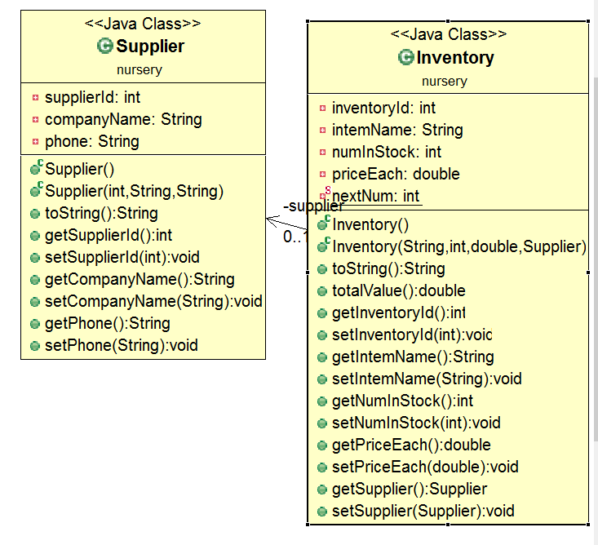

Write the programs listed above. When you are finished you should have the following programs included in a package named dwolffmod4 (except your name) submitted in a jar file named dwolffmod4.jar. In the lab module, write your comments in the text box (see the syllabus for information). Attach your jar file back in the Assignment and submit it back through the portal.

Step 9. Widget and WidgetDriver
Step 11. Stock and StockDriver
Step 12. Vacation and VacationDriver
Step 13. Quote and QuoteDriver
Step 17. Supplier, Inventory, and NurseryDriver

PLEASE Only include a single package with eleven programs in it.

Output for NurseryDrriver

What is the supplier id?
230
What is the supplier's name?
Dirt, Inc.
What is the supplier's phone number?
444-5555
Let's get the items from this supplier. How many are there?
3

What is the nursery item's name for item # 1
Maple
How many are in stock?
30
How much does each cost?
23.95
Maple with id of 1000 has 30 number in stock with a price each of $23.95 and a total value of $718.50.
The item comes from Dirt, Inc. with the id of 230 has a phone number of 444-5555

What is the nursery item's name for item # 2
Knock Out Roses
How many are in stock?
48
How much does each cost?
8.95
Knock Out Roses with id of 1001 has 48 number in stock with a price each of $8.95 and a total value of $429.60.
The item comes from Dirt, Inc. with the id of 230 has a phone number of 444-5555

What is the nursery item's name for item # 3
Dogwoods
How many are in stock?
22
How much does each cost?
14.95
Dogwoods with id of 1002 has 22 number in stock with a price each of $14.95 and a total value of $328.90.
The item comes from Dirt, Inc. with the id of 230 has a phone number of 444-5555

Typical output expected for VacationDriver

How many vacations are there?
3
How many sales people are there?
4
What is the name of vacation #1?
Roanoke to San Diego
How much does Roanoke to San Diego cost?
350
How many vacations were made in by person #1 for Roanoke to San Diego?
2
How many vacations were made in by person #2 for Roanoke to San Diego?
1
How many vacations were made in by person #3 for Roanoke to San Diego?
3
How many vacations were made in by person #4 for Roanoke to San Diego?
0
6 trips to "Roanoke to San Diego" were sold for $350.00 each, for a total of $2,100.00
What is the name of vacation #2?
Phoenix to San Diego
How much does Phoenix to San Diego cost?
120
How many vacations were made in by person #1 for Phoenix to San Diego?
2
How many vacations were made in by person #2 for Phoenix to San Diego?
3
How many vacations were made in by person #3 for Phoenix to San Diego?
1
How many vacations were made in by person #4 for Phoenix to San Diego?
1
7 trips to "Phoenix to San Diego" were sold for $120.00 each, for a total of $840.00
What is the name of vacation #3?
Roanoke to Miami
How much does Roanoke to Miami cost?
230
How many vacations were made in by person #1 for Roanoke to Miami?
2
How many vacations were made in by person #2 for Roanoke to Miami?
3
How many vacations were made in by person #3 for Roanoke to Miami?
4
How many vacations were made in by person #4 for Roanoke to Miami?
3
12 trips to "Roanoke to Miami" were sold for $230.00 each, for a total of $2,760.00
Thank you for using the Vacation selling program!
StockDriver sample Output
Customer id: 1234
Name of stock: IBM
Number of shares: 200
Price paid per share: 60.00
Current value per share: 65.00
1234 owns 200 shares of IBM worth $65.00 per share. You paid $60.00 per share.
The total cost of the stock is $12,000.00 and the current value is $13,000.00
More stocks to calculate? (true or false)
true
Customer id: 3434
Name of stock: GOOG
Number of shares: 120
Price paid per share: 45.00
Current value per share: 120.00
3434 owns 120 shares of GOOG worth $120.00 per share. You paid $45.00 per share.
The total cost of the stock is $5,400.00 and the current value is $14,400.00
More stocks to calculate? (true or false)
false

Quote/QuoteDriver

Sample Output
Give me a quote to analyze
I love baseball!! Go Rangers!

Which of the following would you like:
1. The number of characters in the quote
2. The quote in all uppercase letters
3. The quote in all lowercase letters
4. The first character in the quote
5. The number of vowels in the string
6. The number of consonants in the string
7. To count the number of occurrences of a specific character in the string
8. Enter an new string
999. Quit the program
CHOICE:
1
The number of characters in the quote is 29

Which of the following would you like:
1. The number of characters in the quote
2. The quote in all uppercase letters
3. The quote in all lowercase letters
4. The first character in the quote
5. The number of vowels in the string
6. The number of consonants in the string
7. To count the number of occurrences of a specific character in the string
8. Enter an new string
999. Quit the program
CHOICE:
2
The quote in all upper case is I LOVE BASEBALL!! GO RANGERS!

Which of the following would you like:
1. The number of characters in the quote
2. The quote in all uppercase letters
3. The quote in all lowercase letters
4. The first character in the quote
5. The number of vowels in the string
6. The number of consonants in the string
7. To count the number of occurrences of a specific character in the string
8. Enter an new string
999. Quit the program
CHOICE:
3
The quote in all lower case is i love baseball!! go rangers!

Which of the following would you like:
1. The number of characters in the quote
2. The quote in all uppercase letters
3. The quote in all lowercase letters
4. The first character in the quote
5. The number of vowels in the string
6. The number of consonants in the string
7. To count the number of occurrences of a specific character in the string
8. Enter an new string
999. Quit the program
CHOICE:
4
The first character of the quote is I

Which of the following would you like:
1. The number of characters in the quote
2. The quote in all uppercase letters
3. The quote in all lowercase letters
4. The first character in the quote
5. The number of vowels in the string
6. The number of consonants in the string
7. To count the number of occurrences of a specific character in the string
8. Enter an new string
999. Quit the program
CHOICE:
5
The number of vowels in the quote is 9

Which of the following would you like:
1. The number of characters in the quote
2. The quote in all uppercase letters
3. The quote in all lowercase letters
4. The first character in the quote
5. The number of vowels in the string
6. The number of consonants in the string
7. To count the number of occurrences of a specific character in the string
8. Enter an new string
999. Quit the program
CHOICE:
6
The number of consonants in the quote is 13

Which of the following would you like:
1. The number of characters in the quote
2. The quote in all uppercase letters
3. The quote in all lowercase letters
4. The first character in the quote
5. The number of vowels in the string
6. The number of consonants in the string
7. To count the number of occurrences of a specific character in the string
8. Enter an new string
999. Quit the program
CHOICE:
7
What character are you looking for?
b
The number of times the character 'b' occurs in the quote is 2

Which of the following would you like:
1. The number of characters in the quote
2. The quote in all uppercase letters
3. The quote in all lowercase letters
4. The first character in the quote
5. The number of vowels in the string
6. The number of consonants in the string
7. To count the number of occurrences of a specific character in the string
8. Enter an new string
999. Quit the program
CHOICE:
7
What character are you looking for?
R
The number of times the character 'R' occurs in the quote is 1

Which of the following would you like:
1. The number of characters in the quote
2. The quote in all uppercase letters
3. The quote in all lowercase letters
4. The first character in the quote
5. The number of vowels in the string
6. The number of consonants in the string
7. To count the number of occurrences of a specific character in the string
8. Enter an new string
999. Quit the program
CHOICE:
7
What character are you looking for?
r
The number of times the character 'r' occurs in the quote is 1

Which of the following would you like:
1. The number of characters in the quote
2. The quote in all uppercase letters
3. The quote in all lowercase letters
4. The first character in the quote
5. The number of vowels in the string
6. The number of consonants in the string
7. To count the number of occurrences of a specific character in the string
8. Enter an new string
999. Quit the program
CHOICE:
8
Give me a new quote to analyze
I am having fun.... are you??

Which of the following would you like:
1. The number of characters in the quote
2. The quote in all uppercase letters
3. The quote in all lowercase letters
4. The first character in the quote
5. The number of vowels in the string
6. The number of consonants in the string
7. To count the number of occurrences of a specific character in the string
8. Enter an new string
999. Quit the program
CHOICE:
1
The number of characters in the quote is 29

Which of the following would you like:
1. The number of characters in the quote
2. The quote in all uppercase letters
3. The quote in all lowercase letters
4. The first character in the quote
5. The number of vowels in the string
6. The number of consonants in the string
7. To count the number of occurrences of a specific character in the string
8. Enter an new string
999. Quit the program
CHOICE:
2
The quote in all upper case is I AM HAVING FUN.... ARE YOU??

Which of the following would you like:
1. The number of characters in the quote
2. The quote in all uppercase letters
3. The quote in all lowercase letters
4. The first character in the quote
5. The number of vowels in the string
6. The number of consonants in the string
7. To count the number of occurrences of a specific character in the string
8. Enter an new string
999. Quit the program
CHOICE:
3
The quote in all lower case is i am having fun.... are you??

Which of the following would you like:
1. The number of characters in the quote
2. The quote in all uppercase letters
3. The quote in all lowercase letters
4. The first character in the quote
5. The number of vowels in the string
6. The number of consonants in the string
7. To count the number of occurrences of a specific character in the string
8. Enter an new string
999. Quit the program
CHOICE:
4
The first character of the quote is I

Which of the following would you like:
1. The number of characters in the quote
2. The quote in all uppercase letters
3. The quote in all lowercase letters
4. The first character in the quote
5. The number of vowels in the string
6. The number of consonants in the string
7. To count the number of occurrences of a specific character in the string
8. Enter an new string
999. Quit the program
CHOICE:
5
The number of vowels in the quote is 10

Which of the following would you like:
1. The number of characters in the quote
2. The quote in all uppercase letters
3. The quote in all lowercase letters
4. The first character in the quote
5. The number of vowels in the string
6. The number of consonants in the string
7. To count the number of occurrences of a specific character in the string
8. Enter an new string
999. Quit the program
CHOICE:
6
The number of consanants in the quote is 8

Which of the following would you like:
1. The number of characters in the quote
2. The quote in all uppercase letters
3. The quote in all lowercase letters
4. The first character in the quote
5. The number of vowels in the string
6. The number of consonants in the string
7. To count the number of occurrences of a specific character in the string
8. Enter an new string
999. Quit the program
CHOICE:
7
What character are you looking for?
?
The number of times the character '?' occurs in the quote is 2

Which of the following would you like:
1. The number of characters in the quote
2. The quote in all uppercase letters
3. The quote in all lowercase letters
4. The first character in the quote
5. The number of vowels in the string
6. The number of consonants in the string
7. To count the number of occurrences of a specific character in the string
8. Enter an new string
999. Quit the program
CHOICE:
7
What character are you looking for?
.
The number of times the character '.' occurs in the quote is 4

Which of the following would you like:
1. The number of characters in the quote
2. The quote in all uppercase letters
3. The quote in all lowercase letters
4. The first character in the quote
5. The number of vowels in the string
6. The number of consonants in the string
7. To count the number of occurrences of a specific character in the string
8. Enter an new string
999. Quit the program
CHOICE:
999
Thanks for playing my game!

